**ASSESSMENT OF MARGINAL WORKERS IN TAMILNADU**

Team Members:

K. Swetha

N. Sandhya

M. Priyadharshini

K. Pooja

Marginal workers, often referring to those on the fringes of the job market, can benefit from data science in various ways. Data analysis can help identify employment trends, enabling policymakers to create targeted programs. Additionally, data-driven platforms can match marginal workers with suitable job opportunities, fostering better employment prospects. Training programs can be optimized through data analysis, aligning skill development with market demands, enhancing the employability of marginalized individuals. Overall, data science plays a vital role in creating more inclusive job markets for marginal workers. let's delve into more detail about how data science can empower marginal workers:

1. Skill Development Programs: Data science can analyse local job markets to identify the most in-demand skills. Training programs can then be tailored to teach marginalized individuals these skills, enhancing their employability.

2. Job Matching Platforms: Data-driven platforms can match marginal workers with suitable job opportunities. By analyzing resumes, job requirements, and employer preferences, algorithms can recommend jobs that align with the worker's skills and experience, increasing the chances of finding suitable employment.

3. Predictive Analytics for Employment Trends: Data science can analyze historical employment data to predict future job trends. This information helps policymakers and organizations create targeted initiatives to support marginalized communities, ensuring that training programs focus on skills relevant to upcoming job opportunities.

4. Personalized Career Counselling: Data analysis can be used to provide personalized career counselling. By understanding an individual's skills, qualifications, and aspirations, counsellors can offer tailored advice on career paths, training programs, and job opportunities, increasing the chances of successful employment.

5. Entrepreneurship Support: For marginal workers interested in entrepreneurship, data science can provide insights into market demands. Analyzing consumer behaviour and market trends can help aspiring entrepreneurs make informed decisions about the products or services they want to offer, increasing their chances of establishing successful businesses.

6. Workforce Diversity Analysis: Employers can use data science to analyze their workforce diversity. By understanding the demographics of their employees, companies can implement inclusive hiring practices, ensuring that marginalized communities are not discriminated against in the hiring process.

7. Performance Monitoring and Feedback: In workplaces, data science can be used to monitor employee performance and provide constructive feedback. For marginal workers, this feedback loop is crucial for skill improvement and career growth, enhancing their long-term employability prospects.

8. Policy Formulation: Governments and NGOs can use data science to assess the effectiveness of existing policies aimed at supporting marginalized workers. By analyzing the outcomes of various initiatives, policymakers can refine existing programs or create new ones that are more impactful and responsive to the needs of the marginalized workforce.

In summary, data science equips policymakers, organizations, and individuals with valuable insights, enabling tailored support for marginal workers. This targeted approach increases their chances of finding meaningful employment, thereby improving their quality of life and contributing to a more inclusive society.

**Design thinking** :

Applying a design thinking approach to address the challenges faced by marginal workers involves empathizing with their needs, defining the problems they encounter, ideating innovative solutions, prototyping these solutions, and testing them for effectiveness. Here's how it can be applied step by step: 1. Define: Clearly define the specific problems and pain points faced by marginal workers based on the insights gathered. Frame the problem in a way that focuses on improving their working conditions, job security, and overall well-being. 2. Empathize: Conduct in-depth interviews and observations to understand the daily lives, struggles, and aspirations of marginal workers. Empathize with their experiences to gain insights into their unique challenges.

**Data Analysis:**

To assess the marginal workers in Tamil Nadu for socioeconomic problems, we can consider various Clustering algorithms such as K-means clustering, Gaussian mixture model(GMM) and Self-Organizing maps, K-Means Clustering : Divide the data into clusters based on characteristics like occupation, income, education and residence to identify groups of marginal workers facing similar issues. Gaussian Mixture Model(GMM): This probabilistic model can be used to identify different Gaussian distributions within the marginal worker population, highlighting variations in socio economic conditions. Self-Organizing Maps(SOM): Use SOMs to create a 2D representation of the high-dimensional data, making it easier to visualize clusters of marginal workers. The choice of clustering method should depend on the nature and size of your dataset and the specific objectives of your socioeconomic assessment. It’s essential to preprocess and analyze the data carefully to derive meaningful insights for addressing the problems of marginal workers in Tamilnadu.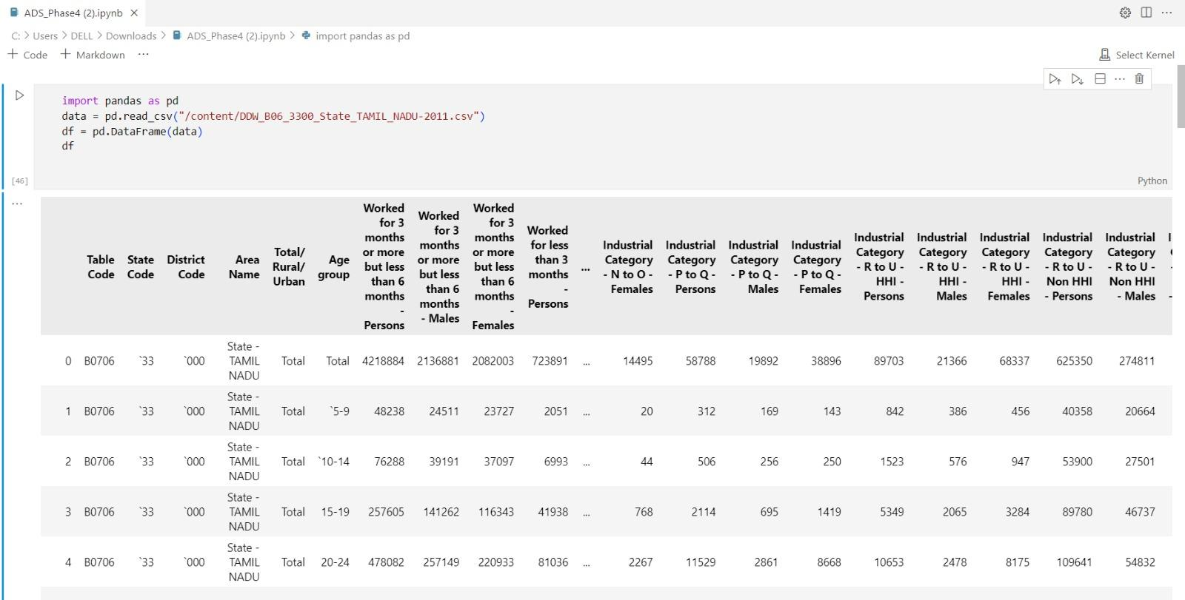

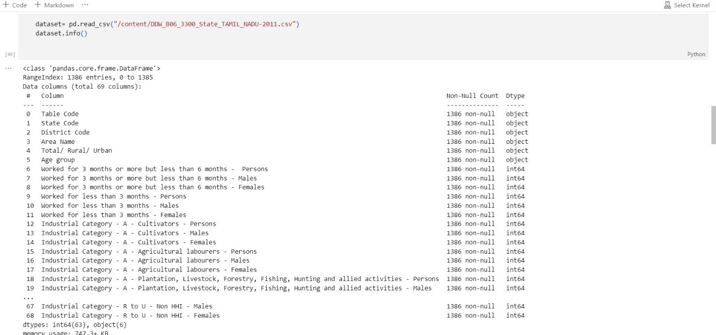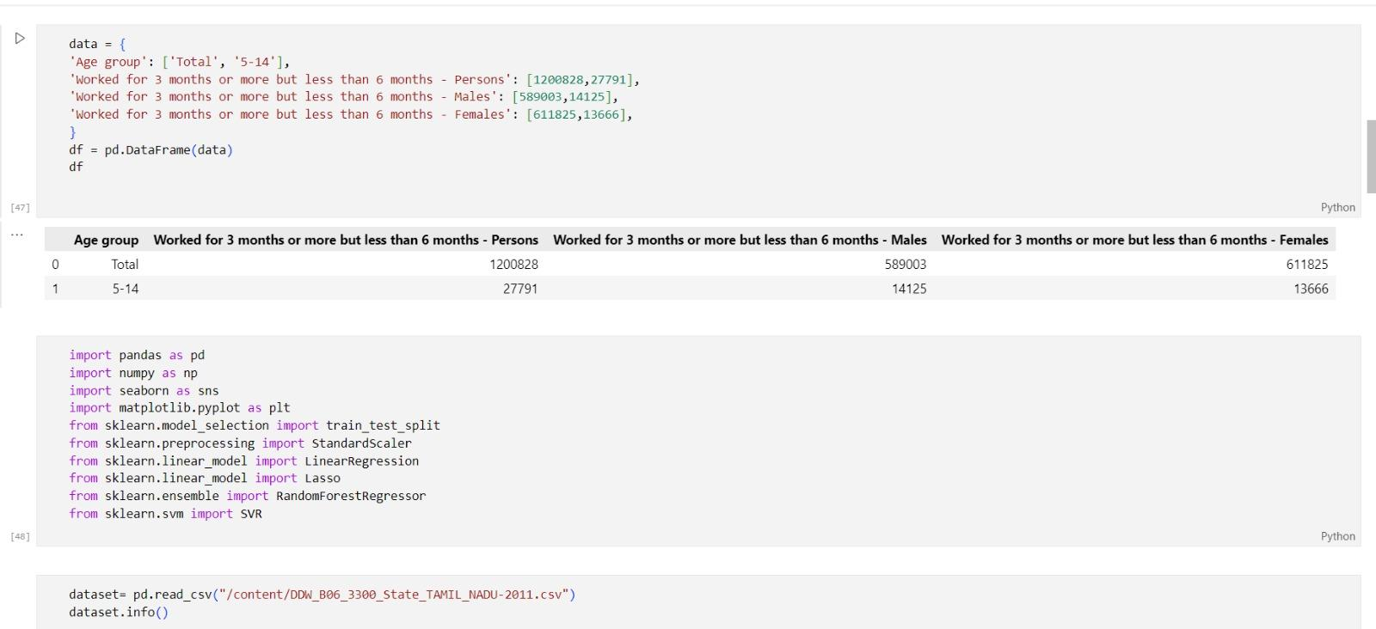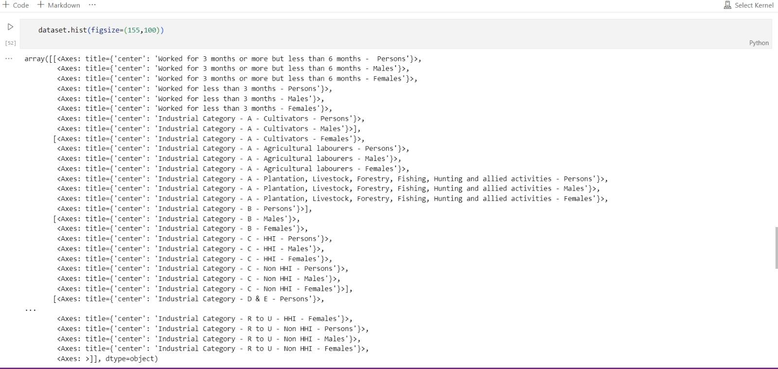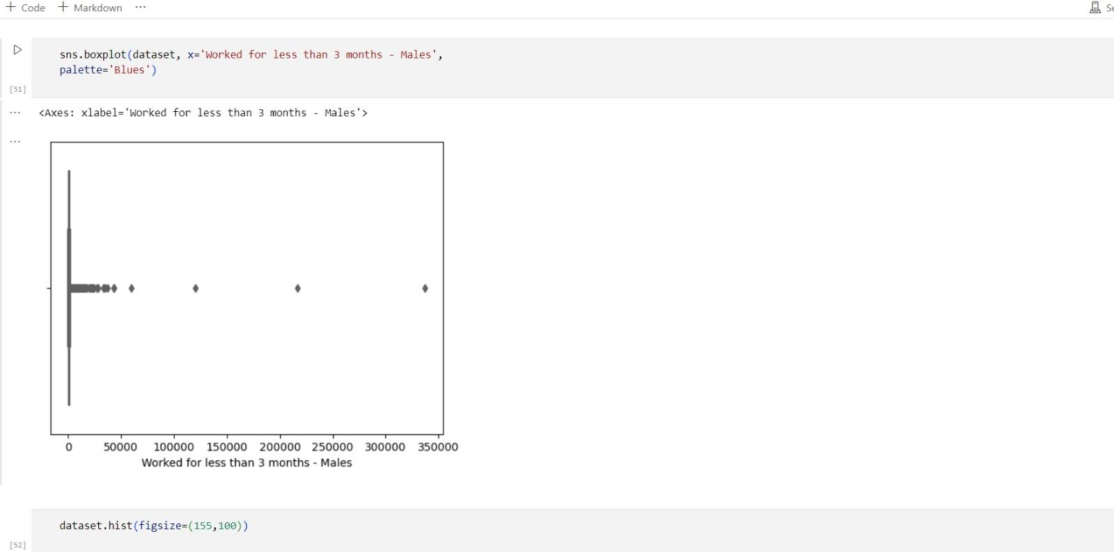

In Python, a function is a reusable block of code that performs a specific task or a set of related tasks. Functions are a fundamental concept in programming and are used to encapsulate a sequence of instructions into a named entity.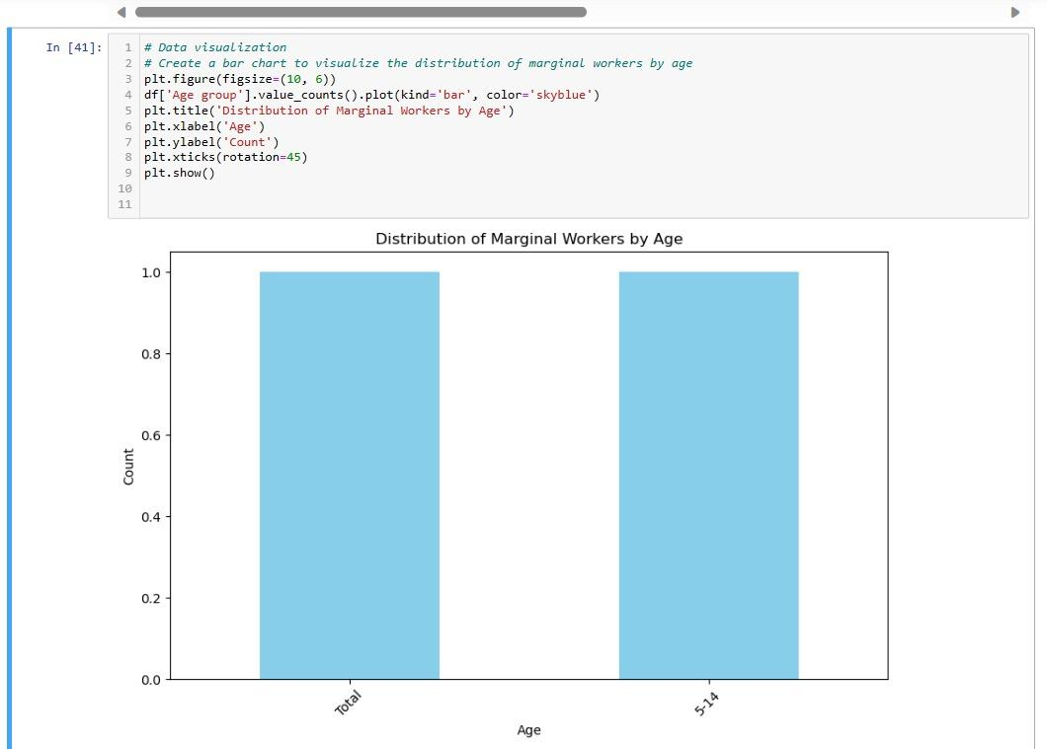

A box plot, also known as a box-and-whisker plot, is a graphical representation of the distribution of a dataset. It provides a summary of key statistical features, making it easier to understand the data's central tendency, spread, and presence of outliers.

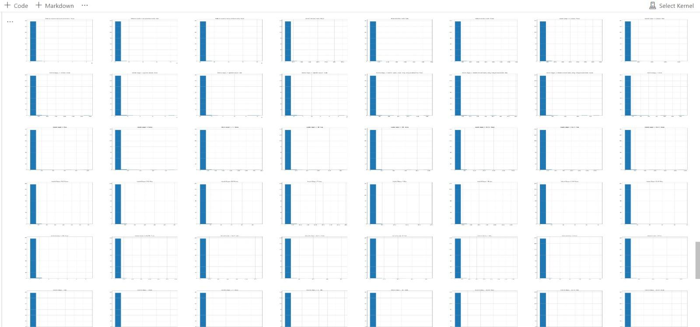

A bar chart is a popular and effective data visualization tool used for representing data in a graphical format.

**Conclusion :**

In conclusion, addressing the challenges faced by marginal workers is a crucial

endeavour that requires a multifaceted approach. These workers, often engaged in irregular and

insecure employment, deserve attention and support to enhance their well-being and livelihoods.

Implementing effective solutions involves understanding their unique needs, advocating for their rights, and providing access to education and skill development programs.